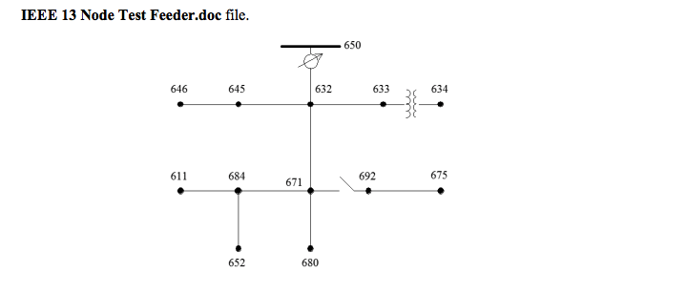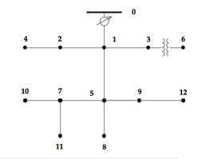
(re-labeling)

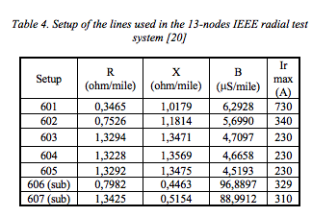

sendingNodes | receivingNodes | lineLengths (feet) | lineConfigs (ohm/mile)
632 | 645 | 500 | 603
632 | 633 | 500 | 602
633 | 634 | 0 | Transformer
645 | 646 | 300 | 603
650 | 632 | 2000 | 601
684 | 652 | 800 | 607
632 | 671 | 2000 | 601
671 | 684 | 300 | 604
671 | 680 | 1000 | 601
671 | 692 | 0 | Breaker
684 | 611 | 300 | 605
692 | 675 | 500 | 606

Line R and X:

Length (feet) * 0.0003048(feetkm) * (ohm/mile) / 1.609344(mile/km)

% spot load data
s_611= [0; 0; 170+80i]; % spot load at node 611 and the units in kW and KVAR. Y-I
s_634= [160+110i; 120+90i; 120+90i]; % Y-PQ
s_645= [0; 170+125i; 0]; % Y-PQ
s_646= [0; 230+132i; 0]; % D-Z
s_652= [128+86i; 0; 0]; % Y-Z
s_671= [385+220i; 385+220i; 385+220i]; % D-PQ
s_675= [485+190i; 68+60i; 290+112i]; % Y-PQ
s_692= [0; 0; 170+151i]; % D-I

% distributed load data (kW+kVAR)
d_632= [17+10i; 66+38i; 117+68i]/2; % Y-PQ
d_671= [17+10i; 66+38i; 117+68i]/2; % Y-PQ

